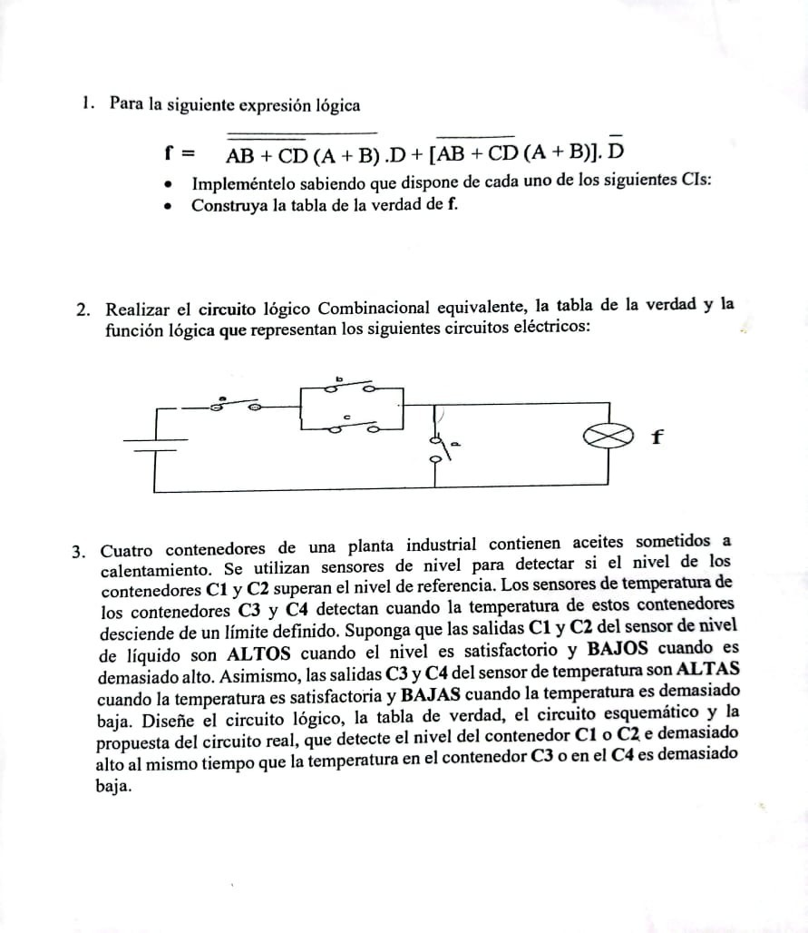

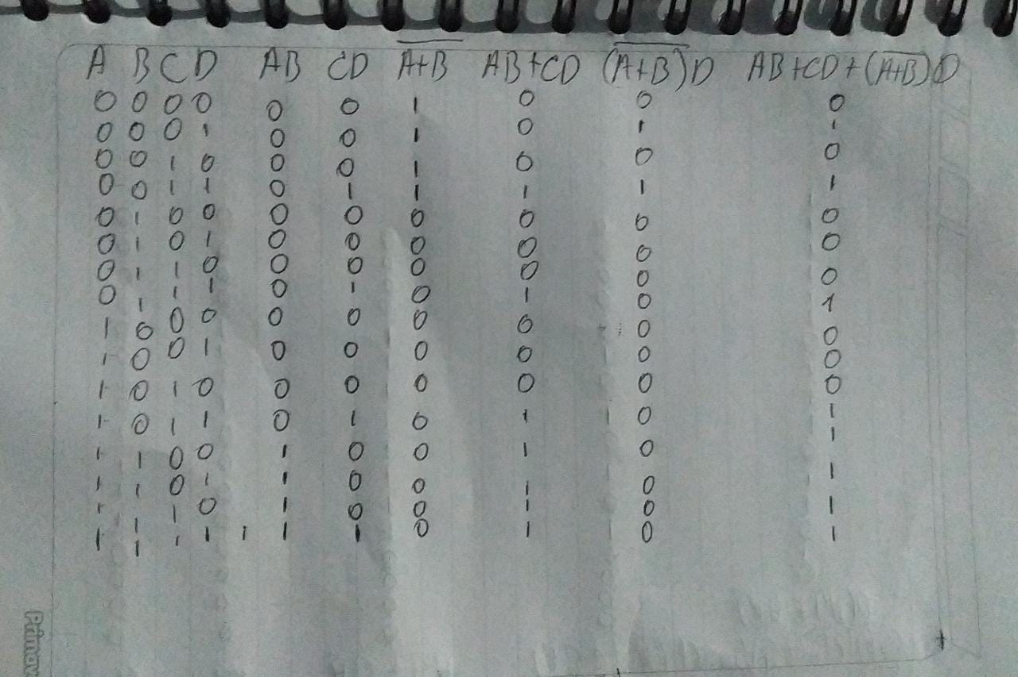1).  
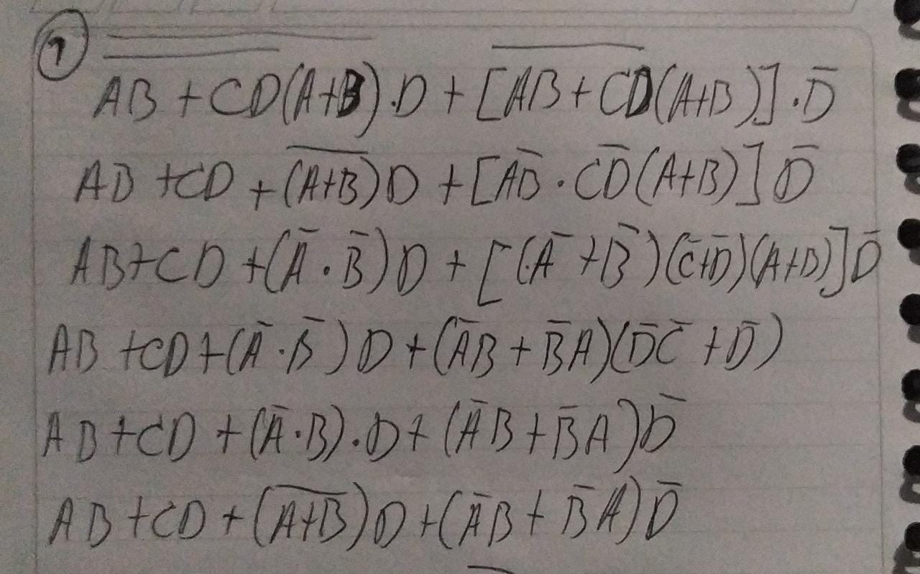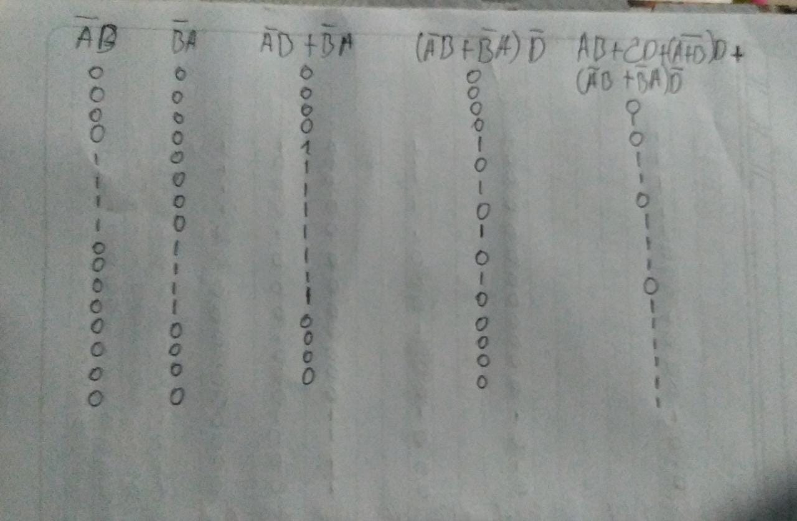

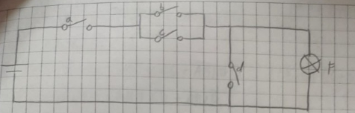2).

$$A\overline{B}C\overline{D}+AB\overline{C}\overline{D}+ABC\overline{D} \\ A\left(\overline{B}C\overline{D}+B\overline{C}\overline{D}+BC\overline{D}\right) \\ A\left(\overline{B}C\overline{D}+B\left(\overline{C}\overline{D}+C\overline{D}\right)\right) \\ A\left(\overline{B}C\overline{D}+B\left(\overline{D}+\overline{D}\right)\right) \\ A\left(\overline{B}C\overline{D}+B\overline{D}+B\overline{D}\right) \\ A\overline{D}\left(\overline{B}C+B+B\right) \\ A\overline{D}\left(C+B\right) \\ A\overline{D}C+A\overline{D}B$$

|  |
| --- |
| A B C D S 0 0 0 0 0 0 0 0 1 0 0 0 1 0 0 0 0 1 1 0 0 1 0 0 0 0 1 0 1 0 0 1 1 0 0 0 1 1 1 0 1 0 0 0 0 1 0 0 1 0 1 0 1 0 1 1 0 1 1 0 1 1 0 0 1 1 1 0 1 0 1 1 1 0 1 1 1 1 1 0 |

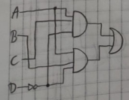

3).

